**07.07.2023 STOCK MANAGEMENT SYSTEM**

**USE CASE DIAGRAM:**

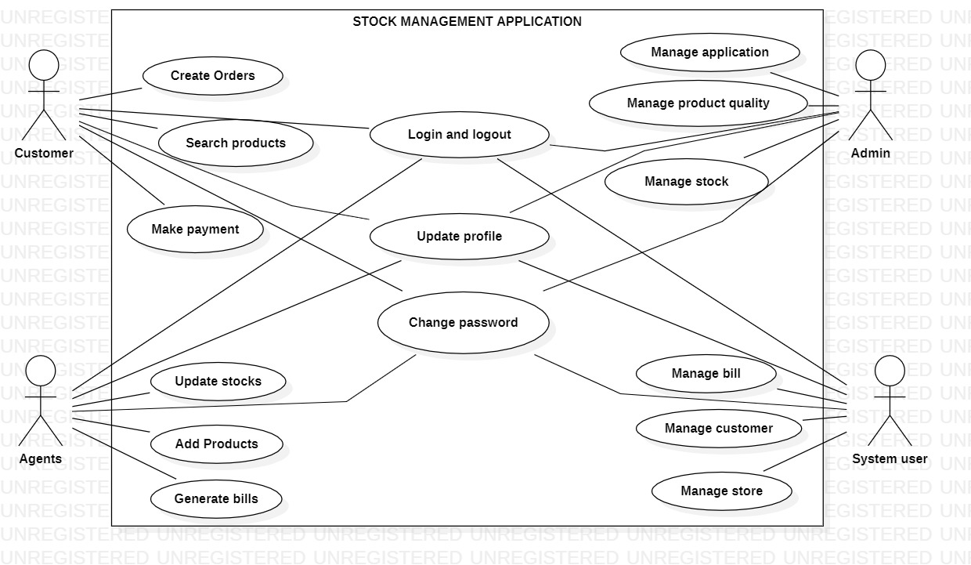

**SEQUENCE DIAGRAM**

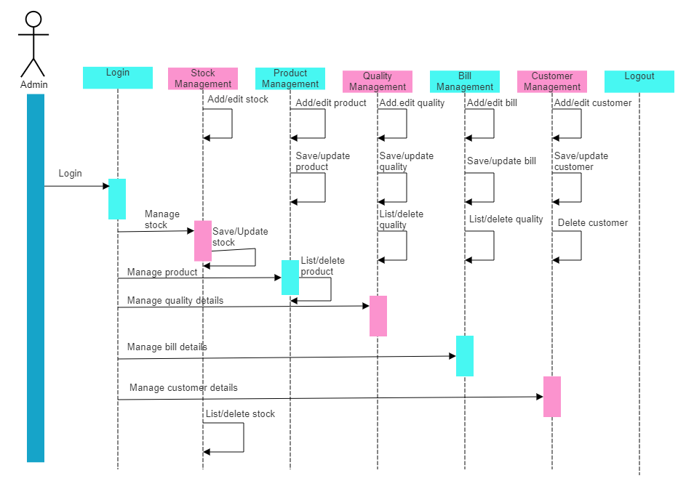

**CLASS DIAGRAM**

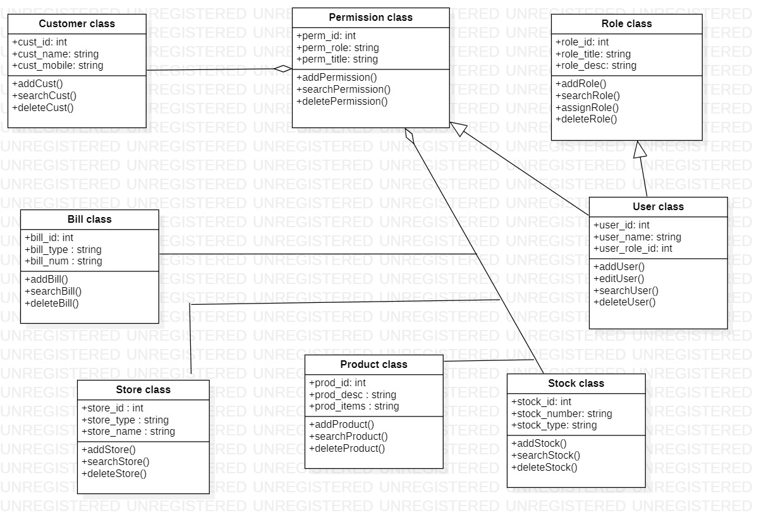

**ER DIAGRAM**

